16.1 Petroleum
Name: ____________________ Class: ____________________ Due date: 1.13
Which fraction from the fractional distillation of petroleum does not match its correct use?
 | fraction | use
A | fuel oil | domestic heating
B | kerosene | jet fuel
C | naphtha | making roads
D | refinery gas | for heating and cooking

The diagram shows different fuels from which electricity can be generated.
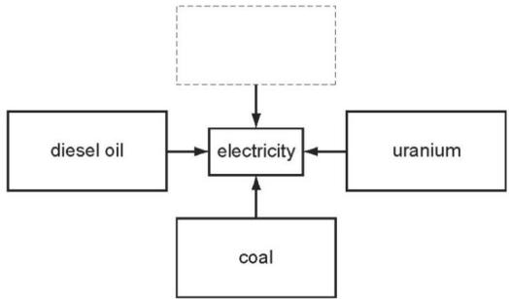
Which box completes the diagram?
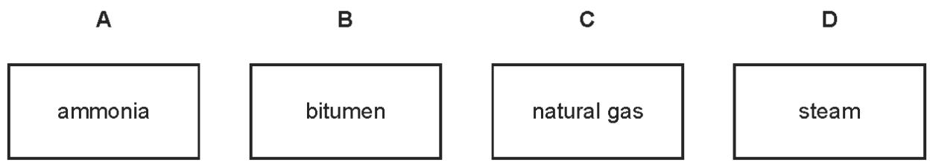
. The diagram shows apparatus used to separate petroleum into four fractions.
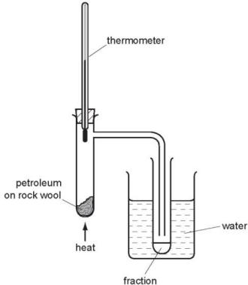
Which fraction contains the smallest hydrocarbon molecules?
fraction | boiling point range/℃
A | up to 70
B | 70 to 120
C | 120 to 170
D | over 170

Which properties of the different compounds in petroleum enable its separation into fractions?
1 boiling point 2 chain length 3 chemical reactivity 4 solubility in water
A 1 and 2 B 1 and 3 C 2 and 4 D 3 and 4
. Which method is used to obtain petrol from petroleum?
A crystallisation B diffusion C filtration D fractional distillation

. Bitumen is a substance obtained from the fractional distillation of petroleum.
Which row describes its boiling point and the size of its molecules?
 | boiling point | size of molecules
A | high | large
B | high | small
C | low | large
D | low | small

. In the flow chart, which fuel could be gasoline?
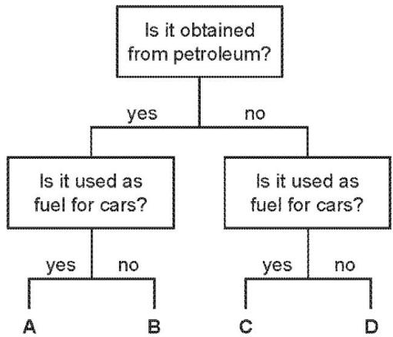

. The table shows some fractions that are obtained from petroleum by fractional distillation, together with some of their uses.
fraction | use
refinery gas | cooking
gasoline | fuel for cars
1 | making chemicals
2 | jet fuel
3 | fuel for ships
bitumen | making roads
Which row correctly identifies fractions 1, 2 and 3?
 | 1 | 2 | 3
A | diesel oil | fuel oil | lubricating fraction
B | fuel oil | diesel oil | kerosene
C | kerosene | naphtha | diesel oil
D | naphtha | kerosene | fuel oil

. Petroleum is a mixture of hydrocarbons which can be separated into fractions using fractional distillation.
Which fraction is used as fuel in jet engines?
A bitumen B gasoline C kerosene D naphtha

. Petroleum is a mixture of different hydrocarbons.
Which process is used to separate the petroleum into groups of similar hydrocarbons?
A combustion B cracking C fractional distillation D reduction

. The table shows the composition of four different types of petroleum (crude oil).
fraction | Arabian Heavy /% | Arabian Light /% | Iranian Heavy /% | North Sea /%
gasoline | 18 | 21 | 21 | 23
kerosene | 11.5 | 13 | 13 | 15
diesel oil | 18 | 20 | 20 | 24
fuel oil | 52.5 | 46 | 46 | 38
Which type of petroleum is best for the motor vehicle industry?
A Arabian Heavy B Arabian Light C Iranian Heavy D North Sea
. Which statement about petroleum is not correct?
A It can be separated into useful substances by fractional distillation.
B It consists mainly of hydrocarbons.
C It is found underground in many parts of the world.
D Its main use is for making lubricants and polishes.

.What is not the correct use for the fraction named?
 | name of fraction | use
A | fuel oil | making waxes
B | gas oil | diesel engines
C | kerosene | jet fuel
D | naphtha fraction | making chemicals

. Which row shows the correct use of a fraction obtained by the fractional distillation of petroleum?
 | fraction | use
A | bitumen | making waxes and polishes
B | fuel oil | aircraft fuel
C | kerosene | fuel for ships
D | naphtha | making chemicals

. The diagram shows the separation of petroleum into fractions.
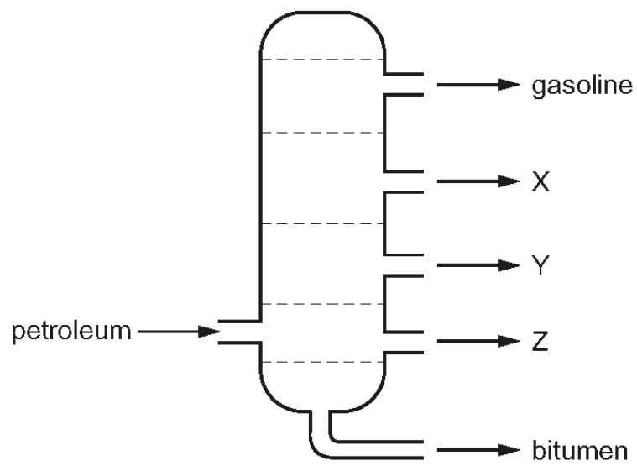
What could X, Y and Z represent?
 | X | Y | Z
A | diesel oil | lubricating fraction | paraffin
B | lubricating fraction | diesel oil | paraffin
C | paraffin | lubricating fraction | diesel oil
D | paraffin | diesel oil | lubricating fraction

. Petroleum is an important fossil fuel.
Which row correctly describes petroleum?
 | type of substance | composition
A | compound | mainly hydrocarbons
B | compound | only hydrogen and carbon
C | mixture | mainly hydrocarbons
D | mixture | only hydrogen and carbon

. Petroleum is separated into fractions.
Which statement is not correct?
A Each fraction contains a mixture of hydrocarbon molecules.
B Fuel oil burns easily and is used as fuel in cars.
C Refinery gas is the fraction containing the smallest molecules.
D The fractions are separated depending on their boiling point range.

. Which list shows the fractions obtained from distilling petroleum, in order of increasing boiling point?
A bitumen $→$ diesel oil $→$ fuel oil $→$ lubricating oil
B diesel oil $→$ gasoline $→$ naphtha $→$ kerosene
C gasoline $→$ naphtha $→$ kerosene $→$ diesel oil
D kerosene $→$ lubricating oil $→$ naphtha $→$ refinery gas

. Which fraction of petroleum is not matched to its correct use?
 | fraction | use
A | bitumen | making roads
B | gasoline | fuel for cars
C | kerosene | fuel for ships
D | naphtha | chemical industry

. The industrial fractional distillation of petroleum is shown.
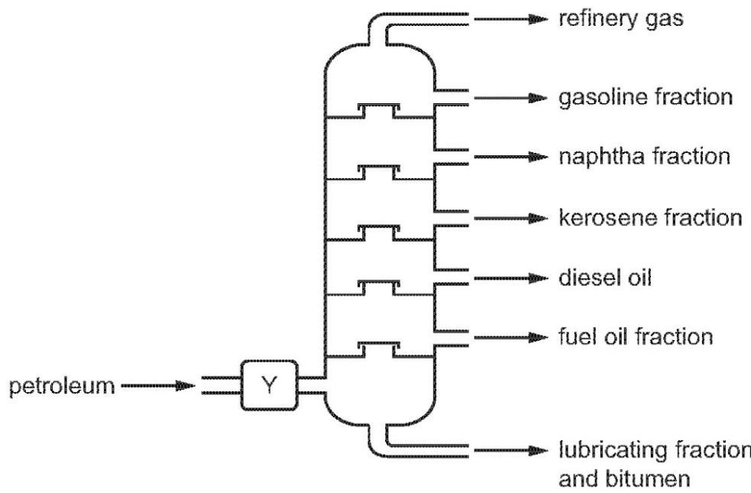
Which process happens at Y?
A burning B condensation C cracking D evaporation

. Fuel oil, gasoline, kerosene and naphtha are four fractions obtained from the fractional distillation of petroleum.
What is the order of the boiling points of these fractions?
 | highest boiling point → lowest boiling point
A | fuel oil → kerosene → gasoline → naphtha
B | fuel oil → kerosene → naphtha → gasoline
C | gasoline → naphtha → kerosene → fuel oil
D | naphtha → gasoline → kerosene → fuel oil

. Some of the fractions obtained from the fractional distillation of petroleum are used as fuels for vehicles.
Which two fractions are used as fuels for vehicles?
A bitumen fraction and gasoline fraction
B bitumen fraction and naphtha fraction
C gasoline fraction and kerosene fraction
D kerosene fraction and lubricating fraction

. Which statement is not correct?
A Petroleum is a mixture of hydrocarbons.
B The main constituent of natural gas is ethane.
C The naphtha fraction of petroleum is used for making chemicals.
D When natural gas burns in air, carbon dioxide and water are formed.

. Fuel oil and naphtha are two fractions obtained from petroleum.
What are the major uses of these fractions?
 | fuel oil | naphtha
A | jet fuel | making chemicals
B | jet fuel | making roads
C | ship fuel | making chemicals
D | ship fuel | making roads

. What is not the correct use of the fraction named?
 | name of fraction | use
A | fuel oil | making waxes
B | gas oil | fuel in diesel engines
C | kerosene | jet fuel
D | naphtha | making chemicals

. Petroleum is separated by fractional distillation.
Which statement about the fractions produced is correct?
A Bottled gas for heating and cooking is obtained from the naphtha fraction.
B Diesel oil is used as a fuel for jet aircraft.
C Substances used to make polishes are obtained from the lubricating fraction.
D The kerosene fraction contains many useful waxes.

. Some fractions obtained from petroleum are listed.
 | fraction | use | position collected in the fractionating column
1 | gasoline | waxes and polishes | below refinery gas
2 | bitumen | making roads | above kerosene
3 | kerosene | jet fuel | below gasoline
4 | refinery gas | heating and cooking | above gasoline
Which rows are correct?
A 1,3 and 4 B 2,3 and 4 C 3 and 4 only D 4 only

. Which statement is correct?
A Bitumen is used as a fuel for ships.
B Coal, natural gas and oxygen are all fuels.
C Hydrogen is the main constituent of natural gas.
D Petroleum is separated into useful substances by fractional distillation.

7. Petroleum contains hydrocarbons which are separated by fractional distillation.
Complete the following definition of a hydrocarbon. A hydrocarbon is a compound which
..........................................................................................................................................................................................................................................................................[2]
ii.Explain what is meant by the term fractional distillation.
.....................................................................................................................................
...................................................................................................................................[2]
Some of the fractions obtained from petroleum are given below.
State a use for each fraction
....................................................................................................................................................................................................................................................................
bitumen lubricating fraction paraffin fraction gasoline fraction
.......................................................................................................................................
......................................................................................................................................
..................................................................................................................................[4]

15 .Natural gas, which is mainly methane, is a fossil fuel.
What is meant by the term fuel?
........................................................................................................................................................................................................................................................................ [1]
ii.Name two other fossil fuels.
.......................................................................................................................................
...................................................................................................................................[2] (iii) Name a solid fuel which is not a fossil fuel.
...................................................................................................................................[1]
Fossil fuels are formed by the anaerobic decomposition of organic matter.
Anaerobic means in the absence of oxygen.
The organic matter contains hydrogen and carbon. Suggest the products that would be formed if the decomposition occurred in the presence of oxygen.
.......................................................................................................................................
..................................................................................................................................[2]
ii.What are the two main disadvantages in the widespread use of fossil fuels?
.......................................................................................................................................
..................................................................................................................................[2]

28 .Petroleum is a source of many important chemicals.
Name two industrial processes which must take place to produce alkenes from petroleum.
.......................................................................................................................................
...................................................................................................................................[2]

29 .Petroleum is a mixture of hydrocarbons. It is separated into useful fractions by fractional distillation. This can be done using the fractionating column shown.
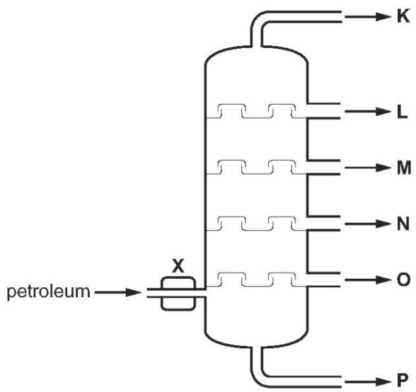
What happens to the petroleum at point X, before it enters the fractionating column?
..................................................................................................................................[1]
ii.State two ways in which fraction O differs from fraction L.
................................................................................................................................[2]

